CS 255 System Design Document Template

UML Diagrams

UML Use Case Diagram
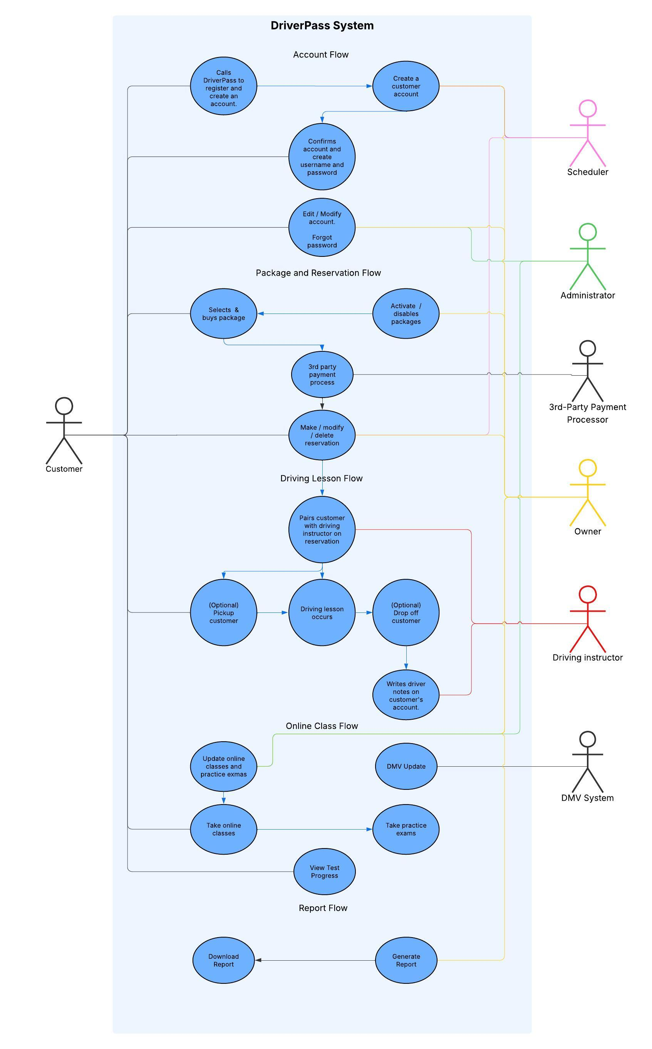

UML Activity Diagrams
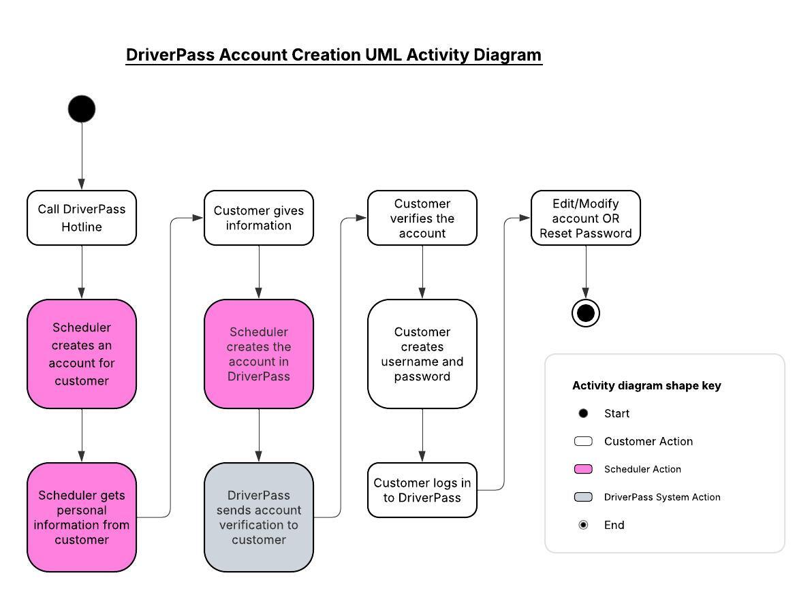

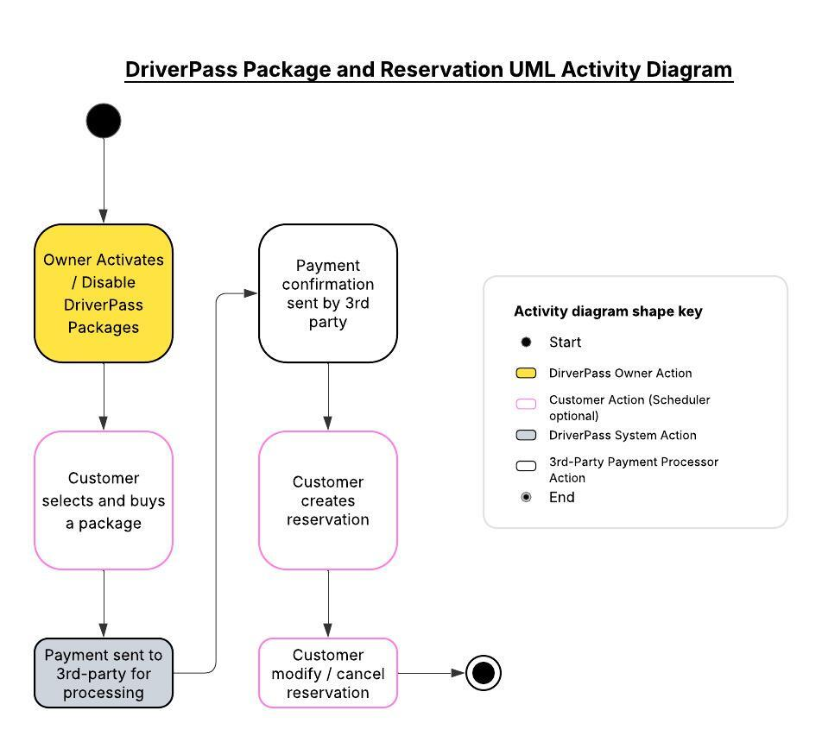

UML Sequence Diagram
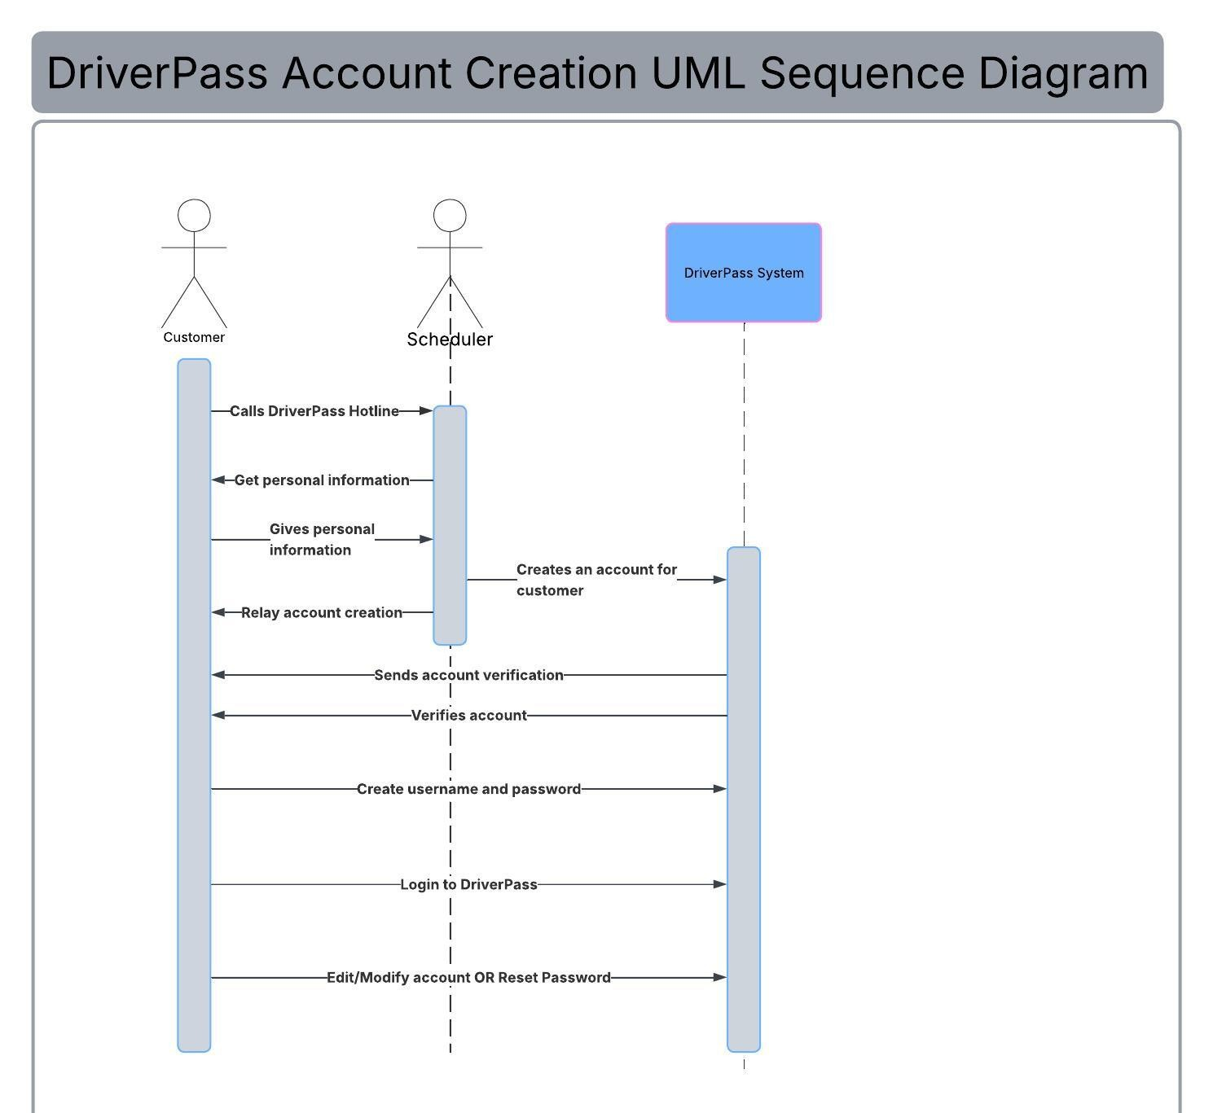

UML Class Diagram
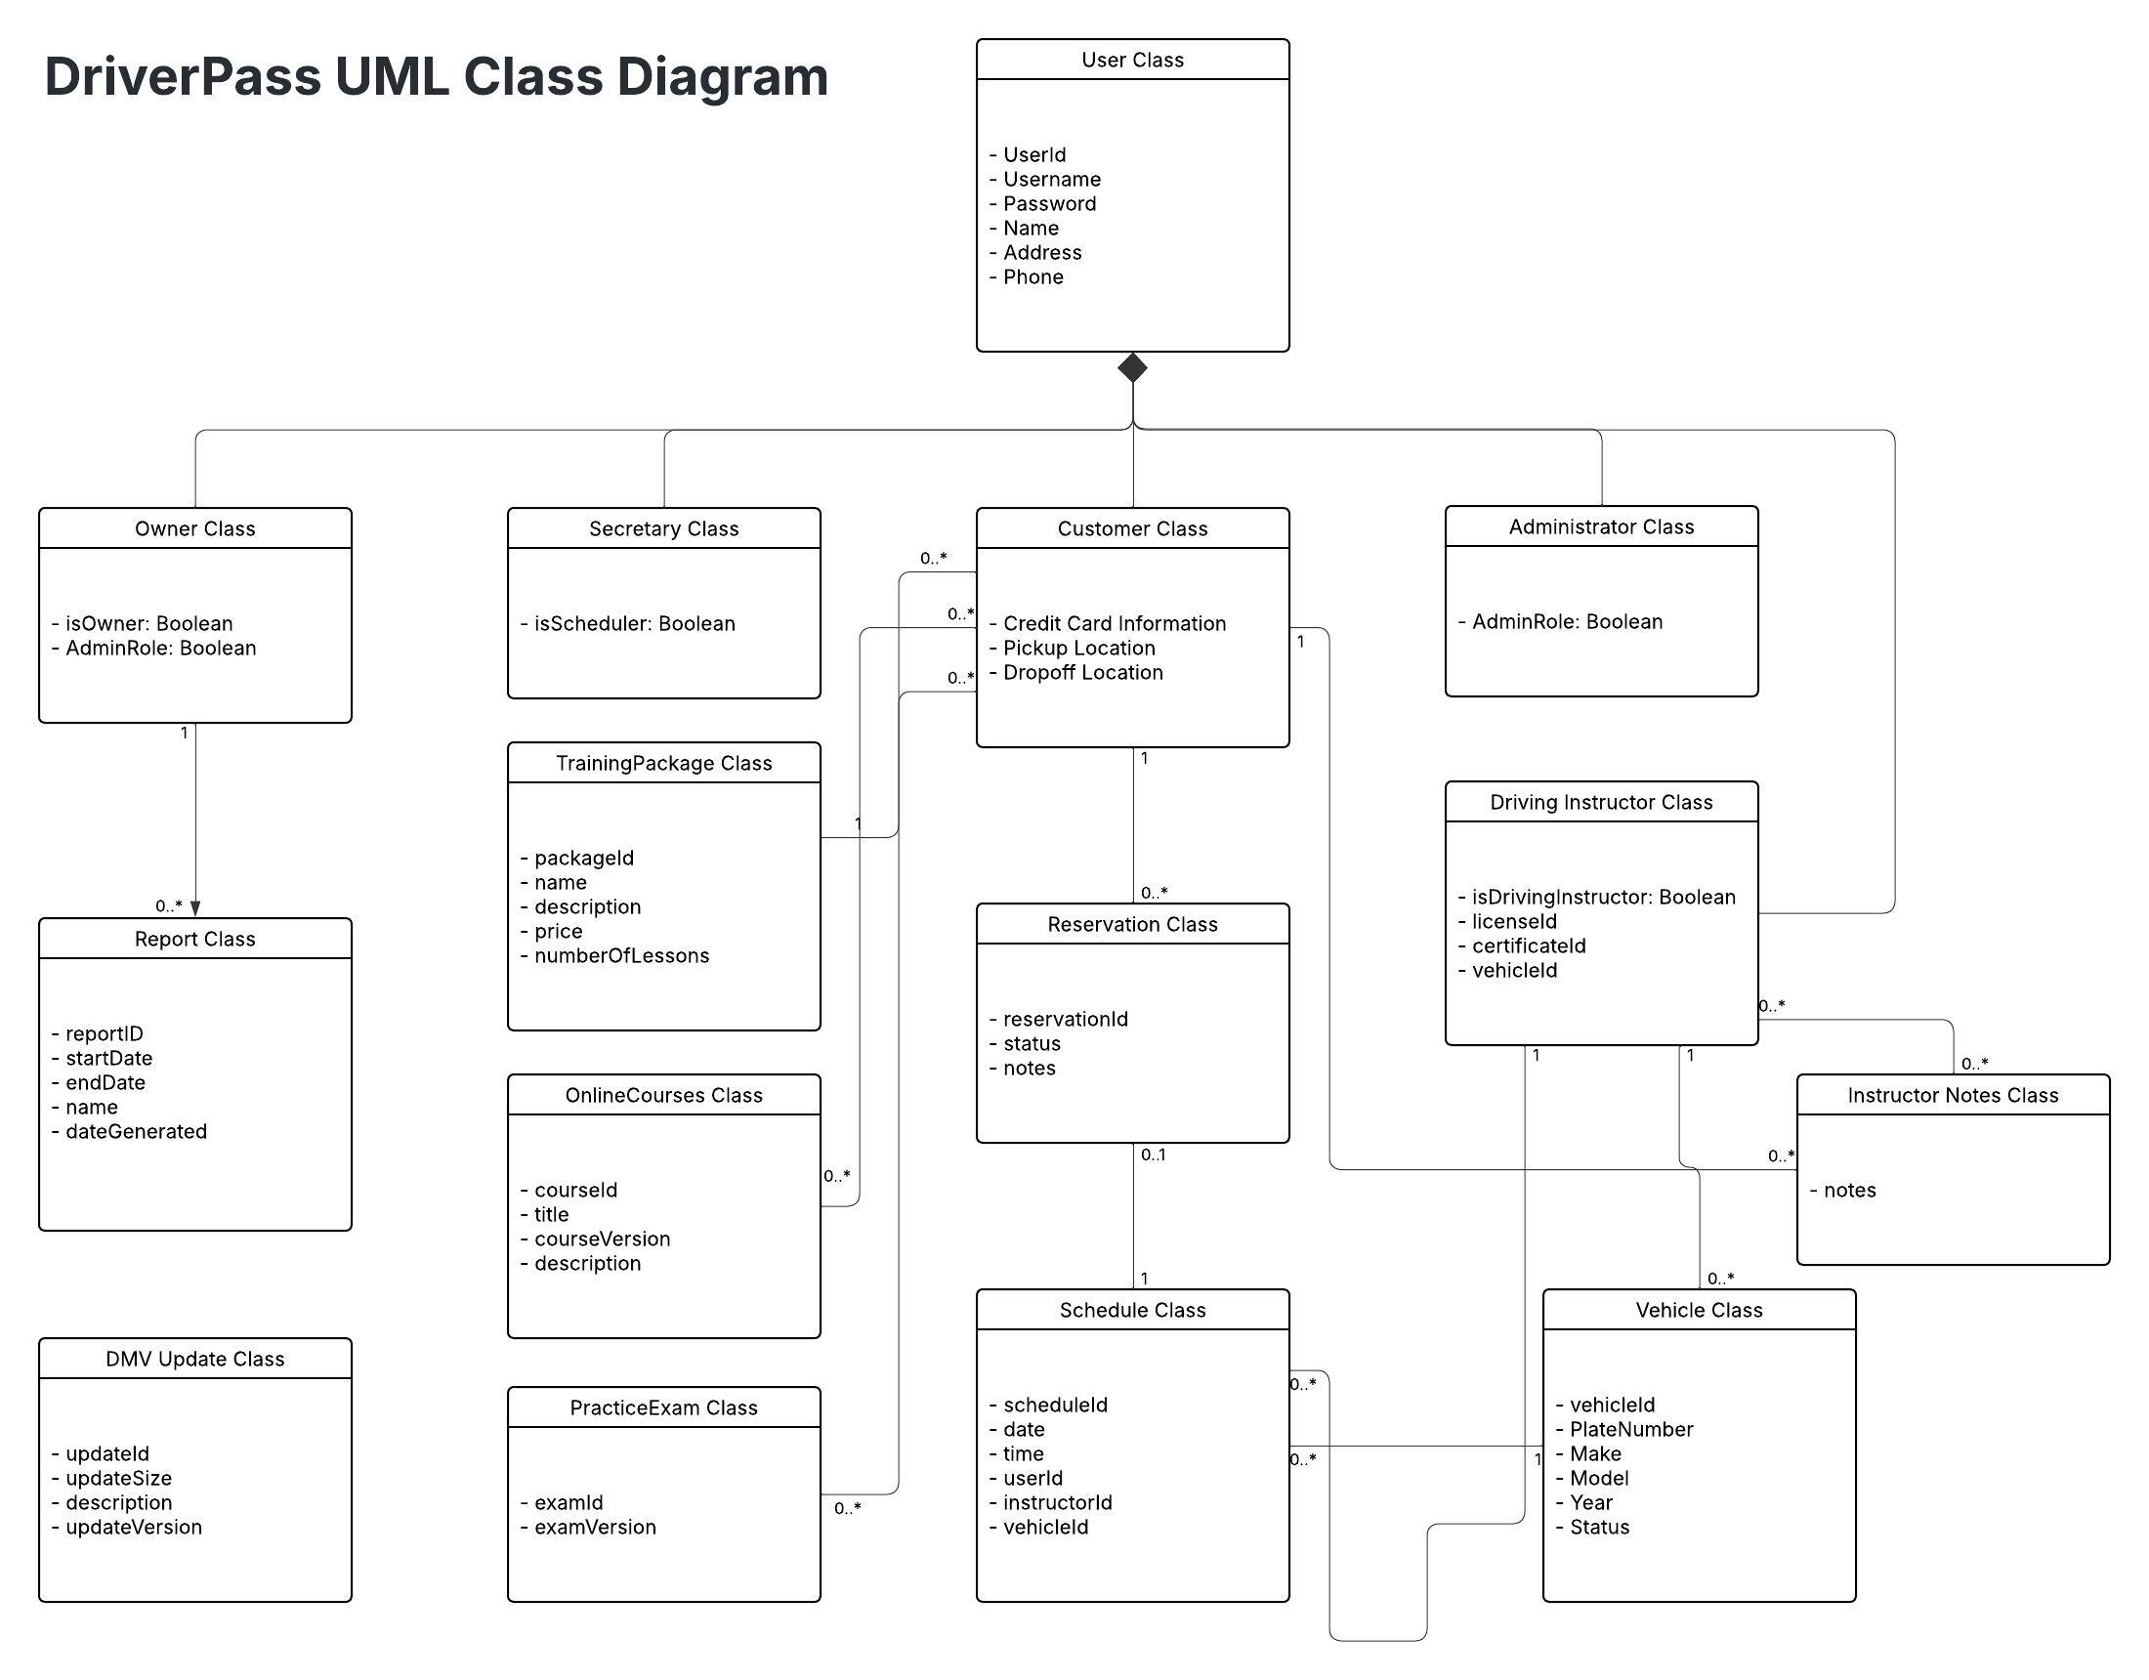

Technical Requirements

Hardware and Infrastructure Requirements
As requested by our client, the DriverPass System requires to be hosted in a secure, cloud-based environment. This provides the best availability, scalability and performance demands with little to no in-house management.

The application’s hardware requirements are as follows:
- Windows Server 2022 Data Center edition (Latest version)
- Minimum of 128 GB of Dedicated RAM
- Minimum of 100 TB of Storage Space SSD NVMe
- Minimum Network Bandwidth of 200Gbps

Software and Tools Requirements
The system requires a device that is capable of running modern web browsers such as Google Chrome, Edge, Firefox, Safari and etc. This ensures all users can access the system securely. HTTPS encryption must be used to meet the highest security requirements for protecting login credentials, personal information, and reservation data.

The system also requires that all users must have a reliable and secure internet connection.

